# EXPERIMENT NUMBER –Practical 9.1

STUDENT’S NAME – Shinde Smita Shahaji

STUDENT’S UID – 20BCS4643

CLASS AND GROUP –CSE-IOT(GROUP B)

SEMESTER – 2ND

**TOPIC OF EXPERIMENT –** WAP to calculate sum of marks of n students of a class inputted via dynamic memory allocation**.**

**AIM OF THE EXPERIMENT –**

**Learn how to use dynamic memory allocation in c++**

FLOWCHART/ ALGORITHM

Start.

Step 1→ Creating a header file for input output stream and define the context and <conio.h > too.

# Step 2 → After that used using namespace std;

Step 3 → Create the int main() member function for passing or declaring the values of int sum; and Number for the number of students.

Step 4→ Then using pre-defined object cout printing enter the number of students asking to user to give input the which I have created in main function.

Step 5→then using new line operator for the initialize a variable while dynamical allocation. The **new** operator is used to **allocate memory at runtime.** The memory is allocated in bytes.

Step 6→Using the for loop take marks of student as input from the user**.**

Step 7→Use another for loop to find the sum of marks and then display it.

Stop.

PROGRAM CODE

#include <iostream>

#include <conio.h>

using namespace std;

int main( )

{

int sum=0, Number;

cout<<"==| smita shinde uid -20BCS4643 |=="<<endl;

cout<<"Enter number of students in Class:\n";

cin>>Number;

int *a = new int[Number];

cout<<"\nEnter "<<Number<<"\nStudents Marks: "<<endl;

for(int i=0; i<Number; i++)

cin>>a[i];

cout<<"Enter Marks are:"<<endl;

for(int i=0; i<Number; i++)

{

cout<<a[i]<<endl;

sum = sum + a[i]; // sum += a[i];

}

cout<<"Total Sum: "<<sum;

delete(a);

getch();

return 0;

}

ERRORS ENCOUNTERED DURING PROGRAM’S EXECUTION

(Kindly jot down the compile time errors encountered)

No error is encountered

PROGRAMS’ EXPLANATION (in brief)

1. We start our program with preprocessor (#) and header file (< iostream >) we have many types of header files but in this program, we used iostream. #include< iostream >, Int main () is a function which work as a container of statements. All the statements are enclosed within the pair of braces { }. “using namespace std” means we use the namespace named std. “std” is an abbreviation for standard. So that means we use all the things with in “std” namespace.
2. we create a pointer object and initialized it to array of numbers with new keyword. New keyword is used for Dynamic memory allocation we use new keyword during initialization of the variable after that we take the marks of students one by one from with the help of for loop and allocate memory all the elements during run time then with the help of for loop we print all the marks which we entered previously then we add all the marks with the help of for loop and display on the screen in the end of the program we use delete keyword for cleaning the memory after the execution of the object and then we execute the program.

OUTPUT

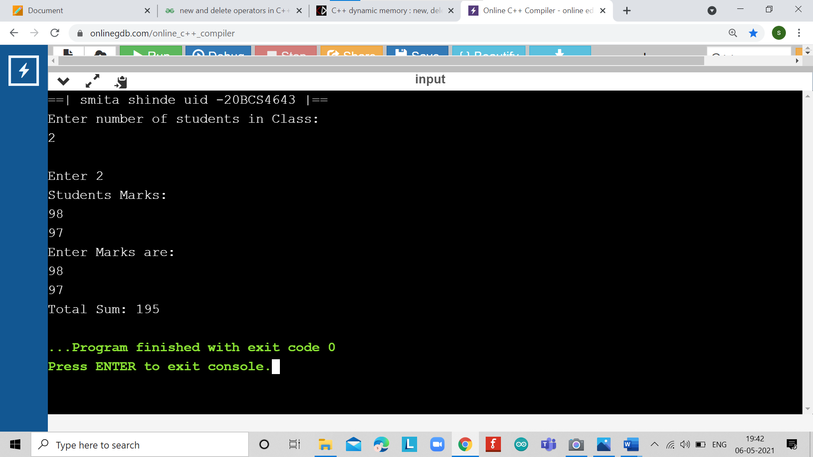

# EXPERIMENT NUMBER –Practical 9.2

STUDENT’S NAME – Shinde Smita Shahaji

STUDENT’S UID – 20BCS4643

CLASS AND GROUP –CSE-IOT(GROUP B)

SEMESTER – 2ND

**TOPIC OF EXPERIMENT** – WAP to allocate memory dynamically for an object of a given class using class’s constructor.

**AIM OF THE EXPERIMENT –**

**Learn how to use dynamic memory allocation in c++**

FLOWCHART/ ALGORITHM

Start.

Step 1→ Creating a header file for input output stream and define the context.

# Step 2 → After that used using namespace std;

Step 3 → Create the class name followed by class student.

Step 4 → Creating the one constructor name followed by class name and one destructor name followed by class name with (~) operator.

# Step 5 → Declare a destructor ~student() for deallocating the memory allocated to the constructor.

Step 6 →Creating int main() dynamic memory will be allocated using the new statement.

Stop.

PROGRAM CODE

#include <iostream>

using namespace std;

class student

{

public:

student()

{

cout<< "Constructor Used" <<endl;

}

~student()

{

cout<< "Destructor Used" <<endl;

}

};

int main()

{

cout<<"==|smita shinde uid- 20bcs4643|=="<<endl;

student* S = new student[3];

delete[]S;

}

ERRORS ENCOUNTERED DURING PROGRAM’S EXECUTION

(Kindly jot down the compile time errors encountered)

No errors encountered

PROGRAMS’ EXPLANATION (in brief)

1. We start our program with preprocessor (#) and header file (< iostream >) we have many types of header files but in this program, we used iostream. #include< iostream >, Int main () is a function which work as a container of statements. All the statements are enclosed within the pair of braces { }. “using namespace std” means we use the namespace named std. “std” is an abbreviation for standard. So that means we use all the things with in “std” namespace.
2. we create a class student in which we create two member functions on is constructor and another is destructor. Then in the main function we create a pointer object and initialized it to array of numbers with new keyword. New keyword is used for Dynamic memory allocation During run time memory is allocated to each object and with the allocation of memory objects will created and then our constructor and destructor called automatically. Then we use delete keyword for cleaning the memory are the execution of the object and in the end, we execute our program.

OUTPUT

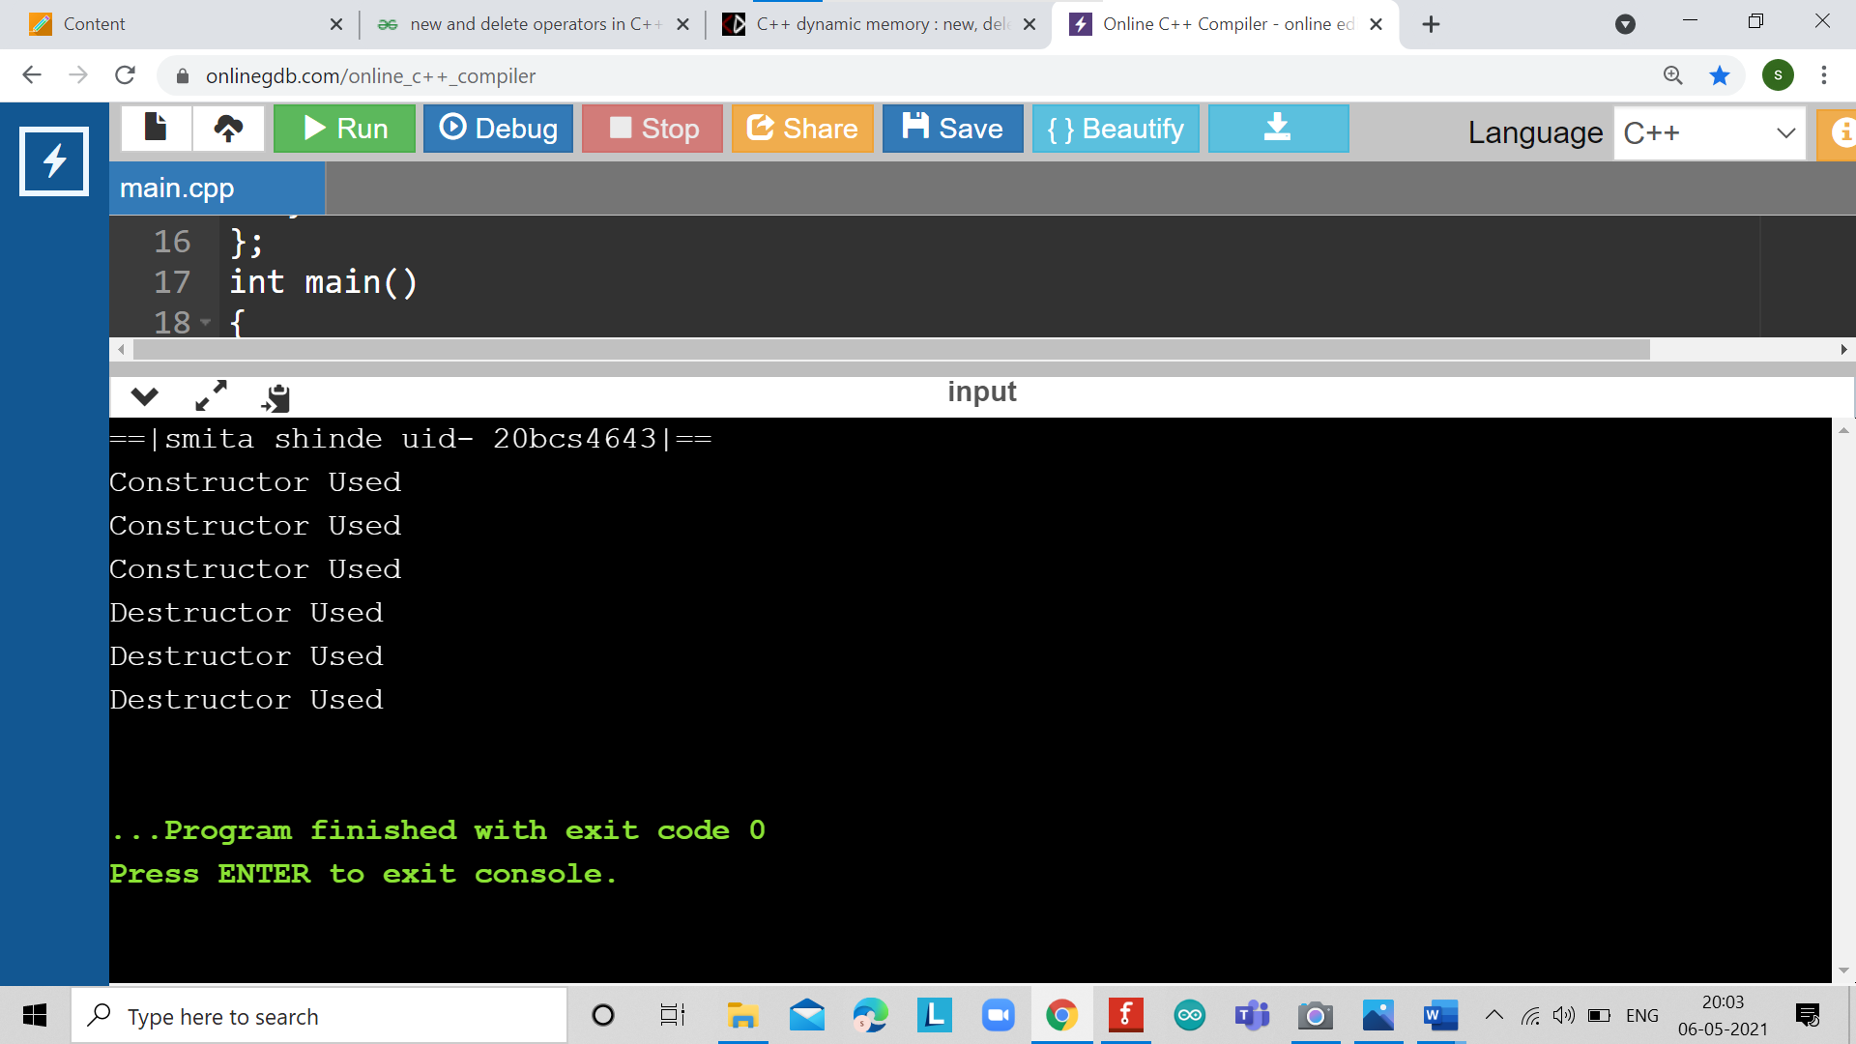

LEARNING OUTCOMES

|  |
| --- |
| * Identify situations where computational methods would be useful. |
| * Approach the programming tasks using techniques learnt and write pseudo-code. |
| * Choose the right data representation formats based on the requirements of the problem. |
| * Use the comparisons and limitations of the various programming constructs and choose the right one for the task. |

EVALUATION COLUMN (To be filled by concerned faculty only)

|  |  |  |  |
| --- | --- | --- | --- |
| **Sr. No.** | **Parameters** | **Maximum**  **Marks** | **Marks**  **Obtained** |
| 1. | Worksheet Completion including writing learning objective/ Outcome | 10 |  |
| 2. | Post Lab Quiz Result | 5 |  |
| 3. | Student engagement in Simulation/ Performance/ Pre Lab Questions | 5 |  |
| 4. | Total Marks | 20 |  |